

Name: Atsuyo Taniguchi / Student ID: 18296

Wells international college

**Project Management**

Assessment Two

|  |  |  |  |
| --- | --- | --- | --- |
| Name of Student | Atsuyo Taniguchi | ID | 18296 |

**Assessment 2 – Research (Online)**

Contents

Instructions: 2

Duration: 2

Multiple-choice Questions: 3

My Learning Notes: 14

What is a project? 14

The important terms of a project 15

Project management basic 16

Project management History 17

Project terminology 18

Document Search Index 20

## Instructions:

This is an individual assessment. Answer all the questions on the document provided by your Trainer.

## Duration:

Trainer will set the duration of the assessment.

## Multiple-choice Questions:

1. 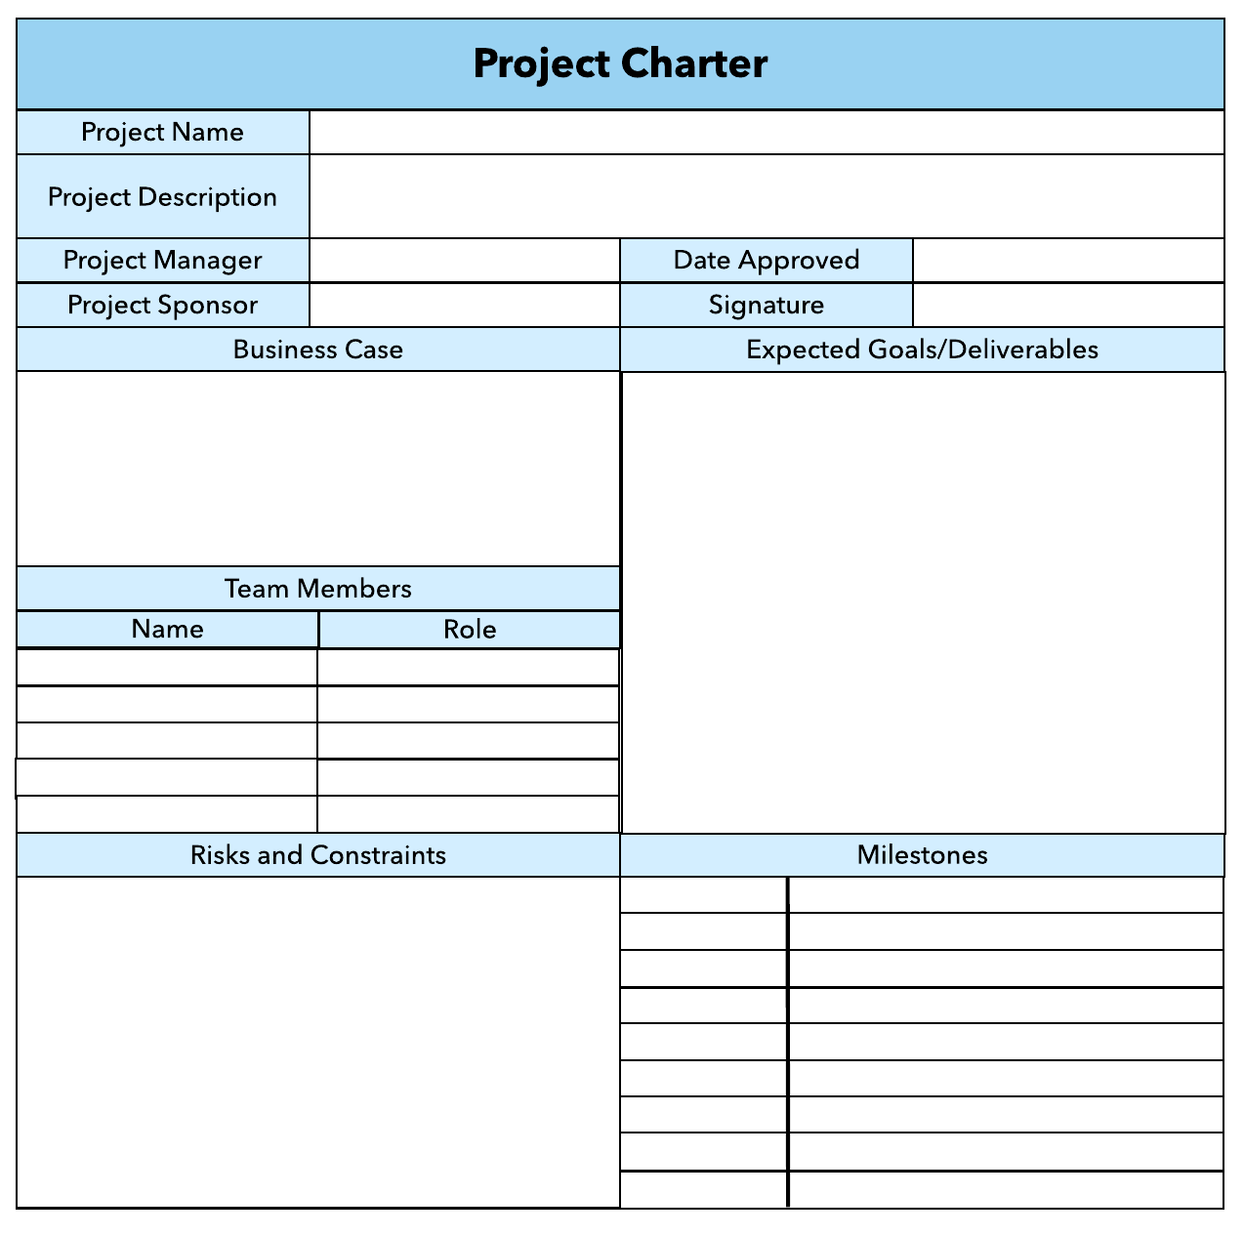What advice do we give about factoring in the commitments of project stakeholders when making your own plans?
   1. Consult student timetables to see when they might be free to attend data collection sessions.
   2. Ask external organizations what the most convenient times would be for you to visit
   3. Neither of these

d) Both A and B

Comment: It is important to inform, influence and involve the stakeholders for their engagement.

Web ref: <https://www.enclaria.com/2015/07/29/stakeholder-engagement-inform-influence-or-involve/>

1. Which of the following are essential components of a GANTT chart used to plan your project?
   1. Your home telephone number
   2. Your supervisor’s home telephone number
   3. The email address for the chair of the ethics committee
   4. None of the above

Comment: In order to get right or good Gantt Chart, you need keep concern time, cost, scope and quality. So will get the good requirement and write good Gantt Chart.

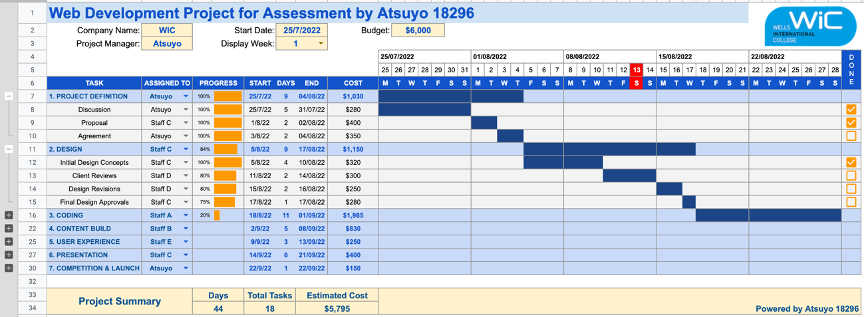Web ref: <https://www.proofhub.com/articles/gantt-charts>

1. The intended outcome of strategy/projects integration is
   1. Clear organization focus
   2. Best use of scarce organization resources
   3. Improved communication across projects and departments
   4. Both A and C are correct
   5. A, B, and C are all correct

Comment: Integration management is a collection of processes required to ensure that the various elements of the projects are properly coordinated. It involves making trade-offs among competing objectives and alternatives to meet or exceed stakeholder needs and expectations.

Web ref: <https://en.m.wikibooks.org/wiki/Project_Management/PMBOK/Integration_Management>

1. 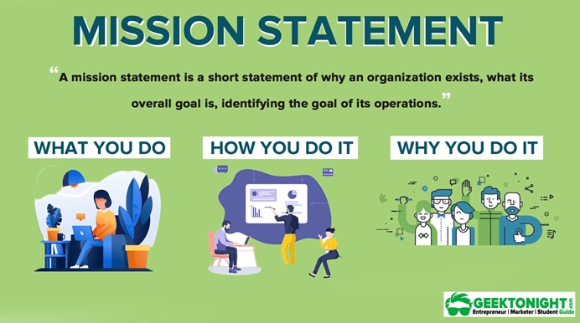Which of the following questions does the organization's mission statement answer?
   1. What are our long-term strategies?
   2. What are our long-term goals and objectives?
   3. How do we operate in the existing environment?
   4. What do we want to become?
   5. All of these are answered by the mission statement

Comment: A mission statement describes what the company core business is and what it does today. Similarly, a vision statement explains the ambition of the company and what it wants to achieve in the future. They are very important because the company vision shapes the culture and guide employees with decisions, behaviours and actions.

Web ref: <https://wind4change.com/mission-vision-statement-values-company-corporate-what/>

1. Which of the following is not one of the requirements for successful implementation of strategies through projects?
   1. Allocation of resources
   2. Prioritizing of projects
   3. 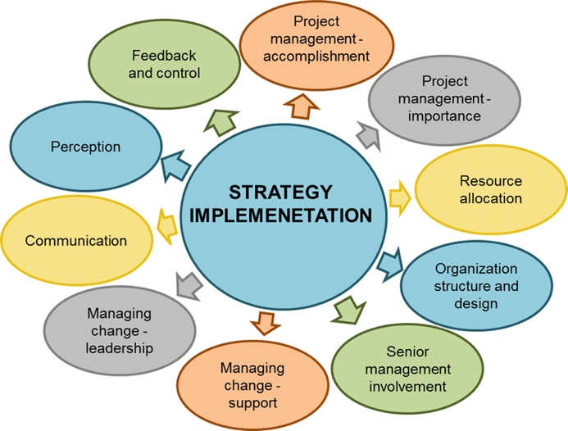Motivation of project contributors
   4. Adequate planning and control systems
   5. All of these are requirements

Comment: Strategy implementation is the process of turning plans into action to reach a desired outcome. The success of every organization rest on its capacity to implement decisions and execute key processes efficiently, effectively, and consistently.

Web ref: <https://online.hbs.edu/blog/post/strategy-implementation-for-managers>

1. 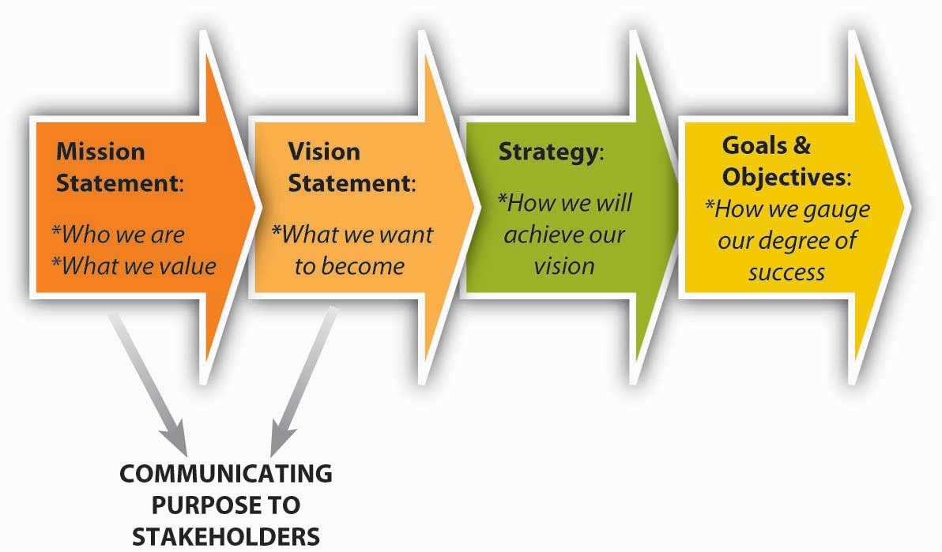Which of the following is the reason(s) why project managers need to understand their organization's mission and strategy?
   1. To make appropriate decisions and adjustments
   2. To be effective project advocates
   3. To be able to get their job done
   4. Both A and B are correct
   5. A, B, and C are all correct

Comment: A good project manager should know enough about the company mission and strategy that they can use it to boost team morale, paint a bigger picture for their staff and gain stakeholder support so that the project could be successful.

Web ref: <https://blog.planview.com/project-managers-care-business-strategy/>

1. 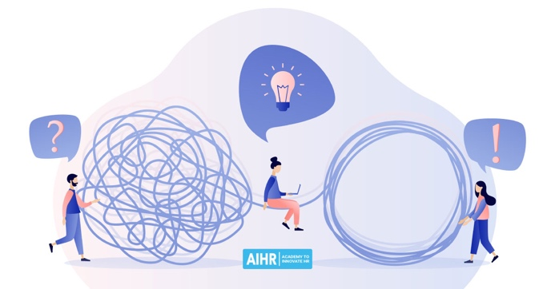Which of these is the highest priority and first strategy required for any organizational change?

a) Communication

* 1. Stress management
  2. Negotiation
  3. Learning
  4. Employee involvement

Comment: Communication is the highest priority and first strategy required for any organizational change. When employees don’t understand why changes are happening, it can be a barrier to driving ownership and commitment, and it may even result in push back.

Web ref: <https://forcivity.com/making-organizational-change-management-a-priority/>

1. Which of the following is not a procedure to obtain an understanding risk in the planning stage (described in ISA 315):
   1. 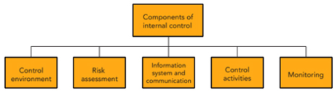Inquiries of management
   2. Analytical procedures
   3. Observation and inspection
   4. Procedures for sampling audit tests

Comment: ISA 315 (Revised) deals with the auditor's responsibility to identify and assess the risks of material misstatement in the financial statements, through understanding the entity and its environment, including the entity's internal control.

Web ref: <http://theglidtz.blogspot.com/p/blog-page_30.html> | <https://leaccountant.com/isa-315-summary/>

1. 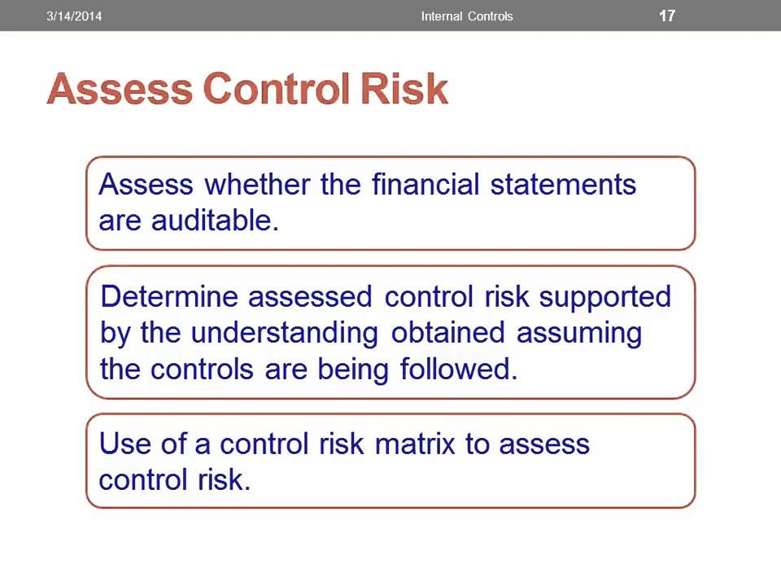Assessment of control risk includes three steps. Which of the following is not one of these steps?
   1. Obtaining an understanding of internal controls and documentation of the controls
   2. Evaluate sufficiency and appropriateness of audit evidence
   3. An initial assessment and response to assessed risk based on the design of internal controls resulting in an audit planning memorandum and audit plan
   4. A final assessment based upon test of controls of operating effectiveness

Comment: Control risk is the risk that a material misstatement would not be prevented, detected or corrected by the accounting and internal control systems.

Web ref: <https://www.iedunote.com/control-risk#:~:text=Assessment%20of%20control%20risk%20is,cycle%20or%20class%20of%20transactions>.

1. 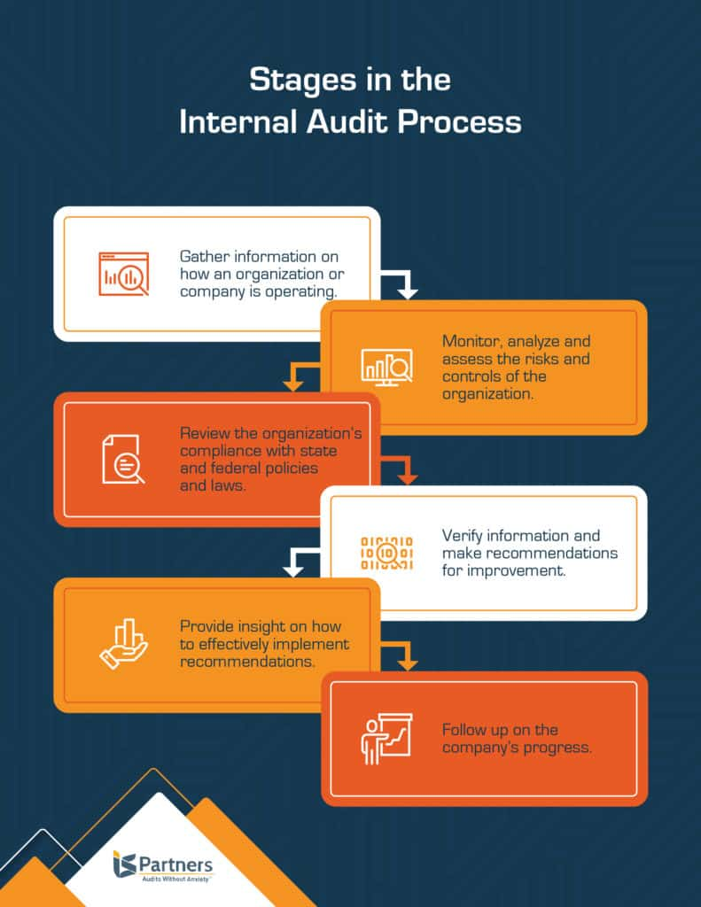Which of the following are not common internal control documentation techniques used by auditors?

a) Questionnaires

* 1. Company internal control manuals
  2. Narrative descriptions
  3. Check lists

Comment: Auditing on a periodic basis are positive experiences for the business aimed at evaluating performance and identifying actionable ways to improve in the future.

Web ref: <https://www.ispartnersllc.com/blog/how-do-internal-audits-work/>

1. 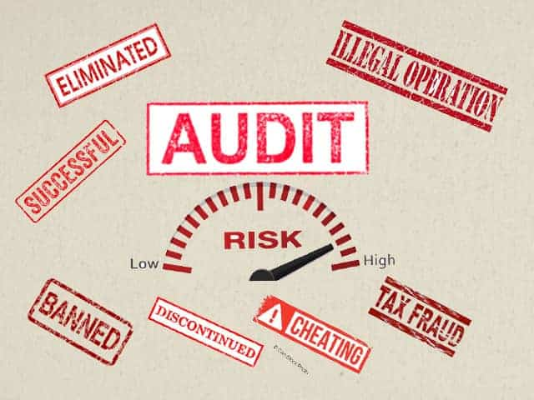Overall response to assessed risk may include:
   1. Identify the absence of key controls (where controls are lacking)
   2. Identify existing controls
   3. Incorporating additional elements of unpredictability in the selection of further audit procedures to be performed
   4. Determine potential material misstatements that could result

Comment: It may include varying the timing of the audit procedures or performing audit procedures on an unannounced basis, etc.

Web ref: <https://pcaobus.org/oversight/standards/auditing-standards/details/AS2301>

1. 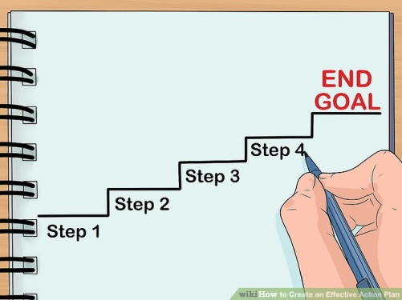Action plan Should be
   1. Specific
   2. Countable
   3. Realistic
   4. Achievable

Comment: An action plan is a detailed plan outlining actions needed to reach one or more goals. Alternatively, businessdictionary.com defines an action plan as a "sequence of steps that must be taken, or activities that must be performed well, for a strategy to succeed".

Web Ref: <https://en.wikipedia.org/wiki/Action_plan>

1. 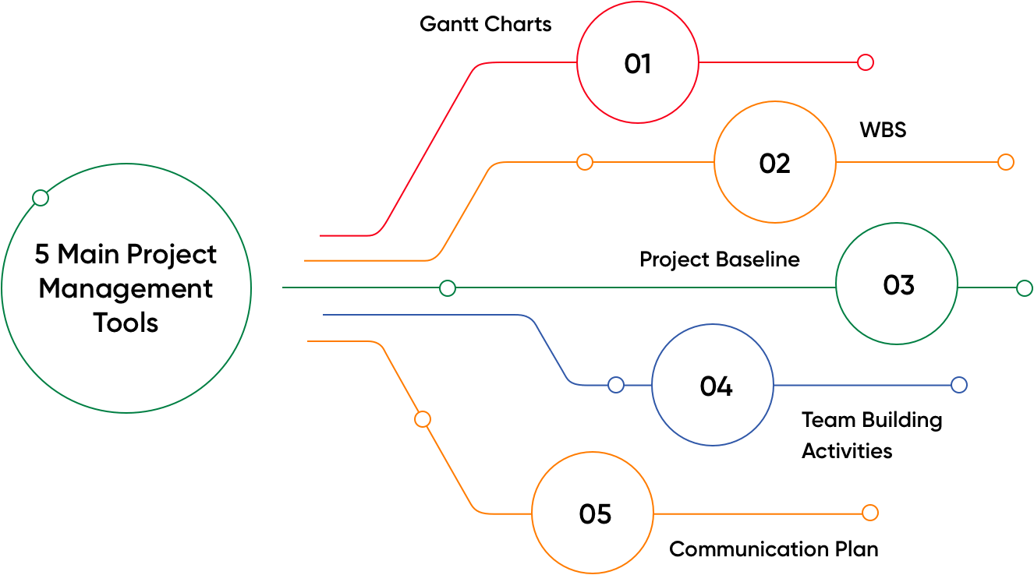Which of the following is not a function of Project Management Tool?
   1. Plan a project
   2. Manage Tasks
   3. Manage Issues
   4. Time Tracking
   5. None of above

Comment: Project management tools can help team members to collaborate effectively and accelerate the projects to meet the specified constraints.

Web ref: <https://www.zoho.com/projects/project-management-tools.html>

1. 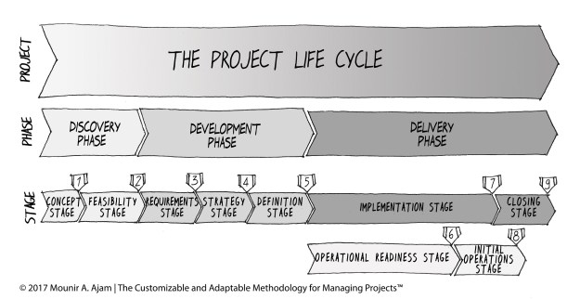John, the project manager for the ERP Project, is about to complete the project phase review. The completion of a project phase is also known as which of the following?
   1. Lesson learned
   2. Kill points
   3. Earned value management
   4. Conditional advancement

Comment: Lessons learned is a collection of information and knowledge gained through an experience within the project. Earned value management (EVM) can happen at different times throughout the project. Conditional advancement is a term that is used to describe the conditions that must be present for the work to continue on a project. They do not happen only at the end of a project phase.

Web ref: <https://certifedpmp.wordpress.com/tag/kill-points/>

1. 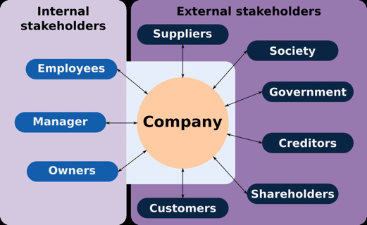Which of the following is not a key stakeholder in a project that creates a service internal to an organization?
   1. The project manager
   2. External customers
   3. Project vendors
   4. Project team members

Comment: Stakeholders are the people or groups who have something to gain or lose from the project’s outcome. In this case, external customers don’t get any effect of this project that changes internal service.

Web ref: <https://www.teamwork.com/project-management-guide/project-stakeholders/>

1. Managing a project is best described as which one of the following?
   1. Establishing direction
   2. Functional controls over the project team and stakeholders
   3. Consistently producing key results expected by stakeholders
   4. Motivating and inspiring the project team to produce results that are expected by project stakeholders

Comment: Managing has to do with consistently producing key results that are expected by stakeholders. A and D describe the leadership processes a project manager must possess, and B, describes the functional management position over project team members.

Web ref: <https://www.lucidchart.com/blog/why-is-project-management-important>

1. You are the project manager for your organization. Influencing your organization requires which of the following?
   1. An understanding of the organizational budget
   2. Research and documentation of proven business cases
   3. An understanding of formal and informal organizational structures
   4. Positional power

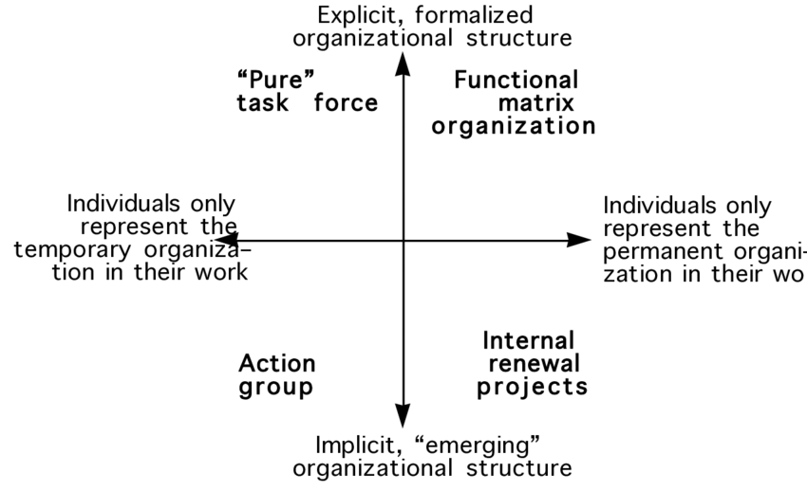Comment: To influence an organization, a project manager must understand the explicit and implied organizational structures within an organization.

Web ref: <https://ctb.ku.edu/en/table-of-contents/structure/organizational-structure/overview/main>

1. 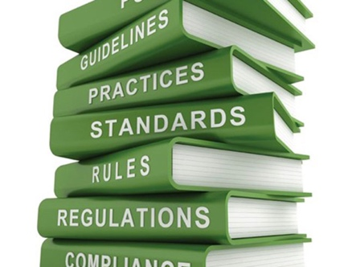What is the difference between a standard and a regulation?
   1. Standards are mandatory; regulations are not.
   2. Standards are optional; regulations are not.
   3. Regulations and standards are essentially the same.
   4. Regulations are usually mandatory; standards may be seen as guidelines.

Comment: Standards are voluntary documents that set out specifications, procedures and guidelines that aim to ensure products, services, and systems are safe, consistent, and reliable. Regulations are government-imposed requirements, which specify product, process or service characteristics, including the applicable administrative provision, with which compliance is mandatory.

Web ref: <https://www.standards.org.au/standards-development/what-is-standard>

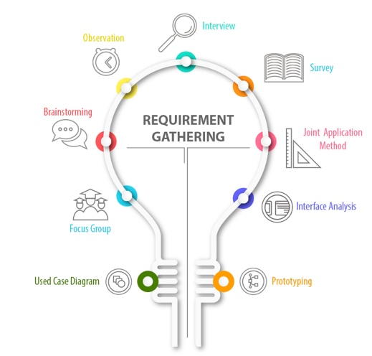 <https://www.riskandresiliencehub.com/do-you-know-the-difference-between-standards-and-regulations/>

1. Which of the following is an example of a deliverable at the end of the requirements-gathering phase in a software design project?
   1. Responsibility matrix creation
   2. Detail design document
   3. Business needs
   4. Project team assembled

Comment: Requirements gathering is the process of identifying your project’s exact requirements from start to finish. The detail design document is an output of the design phase. However, responsibility matrix creation and project team assembled are both a part of the project process, business needs may prompt the project to begin, but not an output of a phase.

Web ref: <https://nmgtechnologies.com/blog/requirement-gathering-solve-biggest-problems-consulting.html>

1. 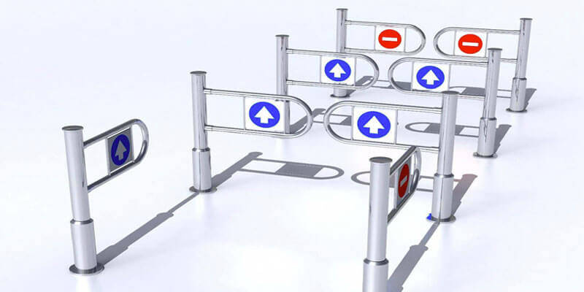At what point in a project would a kill point be acceptable?
   1. When a project team member is not performing as planned
   2. When a project reaches the end of a project phase
   3. When a project reaches the end of its budget
   4. When a project manager determines the project team cannot continue

Comment: Kill points are typically at the end of a project phase. A kill point does not mean the project is killed, just that the potential for termination exists.

Web ref: <https://www.projectmanager.com/training/how-to-know-when-to-kill-a-project>

1. Of the following, which is not an exit criterion?
   1. Customer sign-offs
   2. Quality metrics
   3. Stakeholder analysis
   4. Regulatory inspections

Comment: Exit criteria are the criteria or requirements, which must be met before completing a specific task or a process. Stakeholder analysis is a process of identifying these people before the project begins, grouping them according to their levels of participation, interest, and influence in the project. It’s not an exit criterion.

Web ref: <https://www.whatissixsigma.net/entry-and-exit-criteria/#:~:text=Exit%20criteria%20are%20the%20criteria,work%20can%20be%20deemed%2C%20completed>.

1. At which point is the risk of failure the least but the consequence of failure the highest?

a) During the early stages

* 1. During the middle stages
  2. During the final stages
  3. Risk of failure is even across all project phases

Comment: As the project moves closer to completion, the likelihood of risk diminishes.

Web ref: <https://pm4id.org/chapter/11-3-project-risk-by-phases/>

1. In project estimation, project manager has to provide an expert judgement, which are considered of the following EXCEPT:
   1. 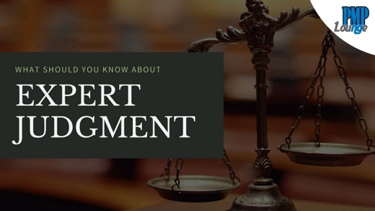Impact of inflation over the project lifecycle
   2. Required labour and labour rates
   3. Material costs and assumptions
   4. Costs of quality
   5. All of above
   6. None of above

Comment: Expert judgment is when you call in an expert to get a skilled opinion. It can be applied to a variety of situations, especially it is often used to assist with cost/ resource/ risk management.

Web ref: <https://asana.com/resources/expert-judgment>

1. 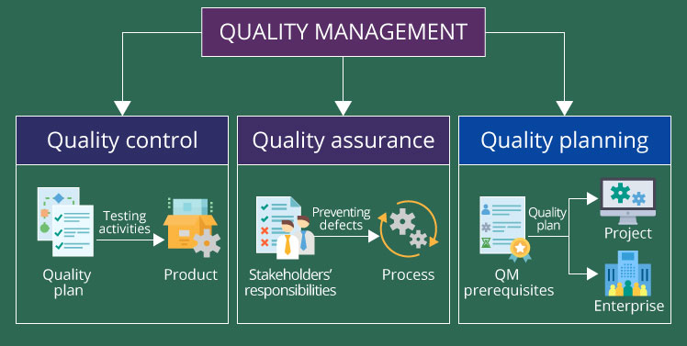Which component is/are included in Quality Management Plan
   1. Quality objectives
   2. Key project deliverables
   3. Quality standards
   4. Quality control and assurance activities
   5. All of above

Comment: A quality management plan is a document that helps the project manager and the project team execute quality management and quality assurance actions. Quality, in the context of project management, is fulfilling the project requirements and meeting the customer’s needs.

Web ref: <https://www.qualio.com/blog/the-9-core-elements-of-a-quality-management-system>

1. What's an activity sequencing
   1. The process for identifying and documenting dependencies among schedule activities
   2. The process for identifying critical activities
   3. The process for identifying ordering and schedule activities
   4. The process for planning the project

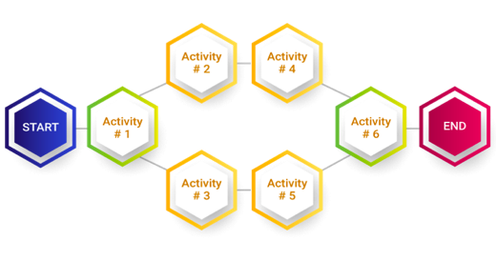Comment: Sequence Activities are the process of identifying and documenting relationships among the project activities. It could help to make your project stage very clear and easy to follow the project progress so that will help the project team work more efficiently.

Web ref: <https://www.futurelearn.com/info/courses/time-management-project-management/0/steps/136200>

## My Learning Notes:

<https://www.youtube.com/watch?v=rBSCvPYGnTc&t=1323s>

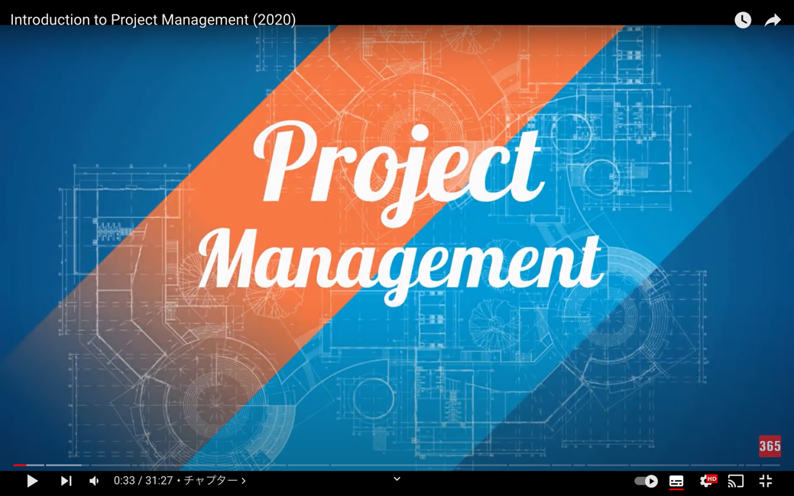

## What is a project?

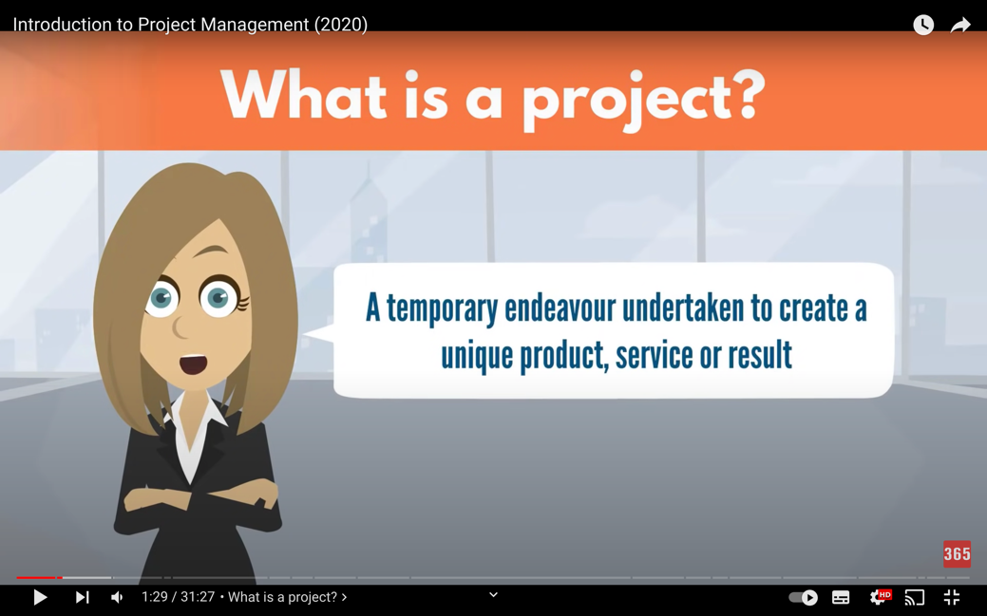

A project is a temporary endeavour undertaken to create a unique product, service or result.

In other words, it’s a temporary initiative that is agreed, planned, and executed to a achieve a specific goal.

## Timeline Description automatically generatedThe important terms of a project

Project can break down with: TIME, GOAL and COST

TIME: it has a predetermined start/end date, and strict expiry date

GOAL: output of the project such as product, service or result, it should be specific

→SCOPE: the output together with the work done to create it, it should be UNIQUE

COST: budgets and the resources specifically dedicated to accomplishing the goal in mind

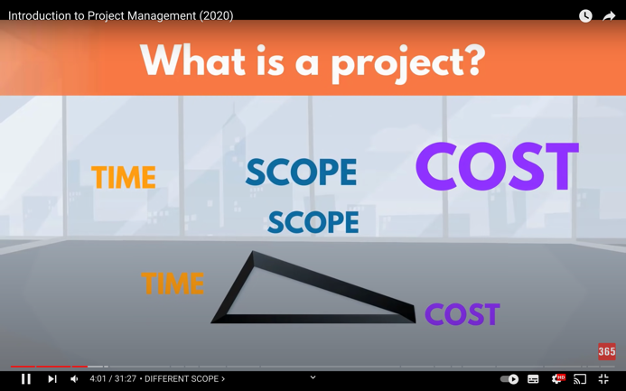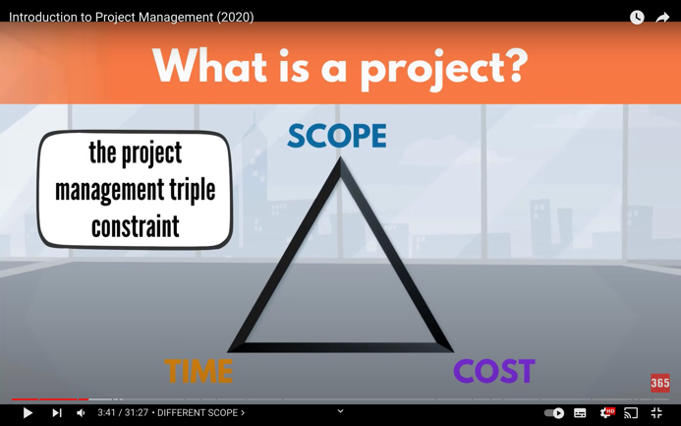**The project management triple constraint: TIME, SCOPE and COST**

Time, scope and cost are dependent on each other:

After determining them at the start, if one of them changes, it will trigger a change in one or both of the others.

i.e., if you need to pull the end date of your project forward…

1) you will need to increase your resources input by spending more

2) you will need to produce fewer products output

Either 1) or 2) or perhaps even both you may need to change them to achieve the project goal

## Project management basic

* A project must relate to a business strategy
* A project manager needs to be accountable for the project success
* It needs to accomplish the specific goal within the prior agreed time and budget constraints to make a project successful
* 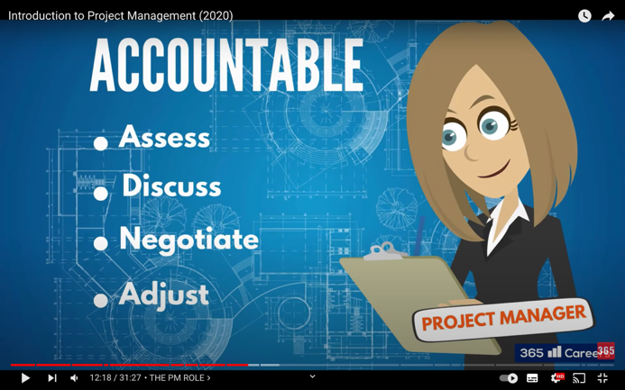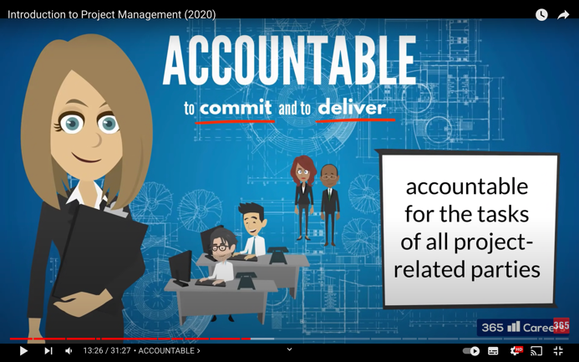PM need to assess a project and deem the constraints practical or otherwise, if otherwise, they must discuss and negotiate to their clients for additional time, resources or an adjustment to the goal itself
* PM need to be accountable for the tasks of all the project-related parties includes project team members, support functions, managers, vendors and other stakeholders
* PM need to full control and visibility on all project-related work and take actions immediately when identifying something is not progressing on track
* PM sometime need to help others overcome their barriers and keep them motivated
* PM need some skills, knowledge and expertise to help them make best decisions and direct the work in the right direction
* PMs’ three major skill sets and essential qualities within them (the image below)

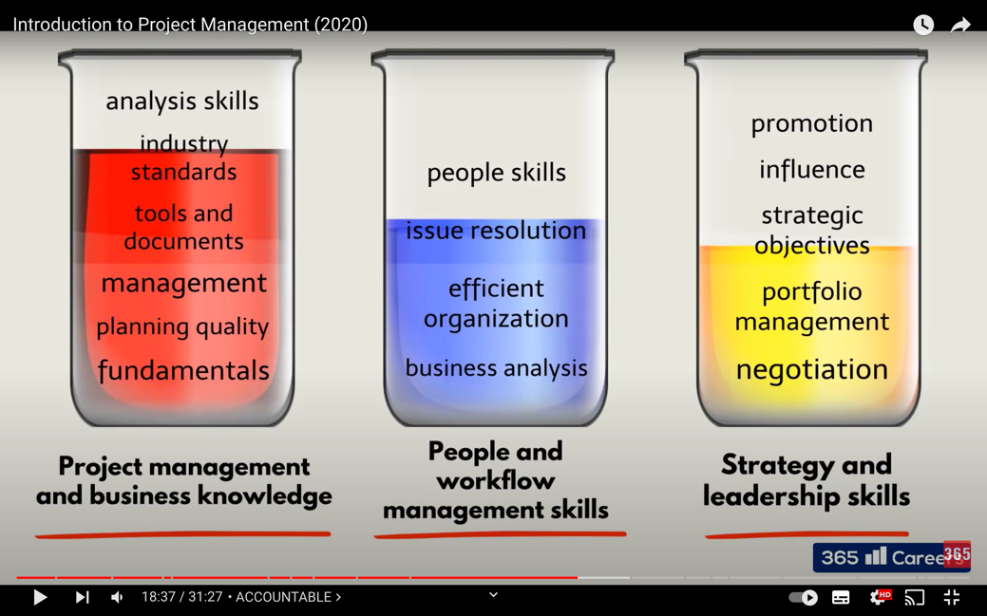

* Attitude and professionalism are paramount, PM must stay positive and goal-oriented all the time
* Being a business professional, PM must show high moral, strong ethics and solid credibility

## Project management History

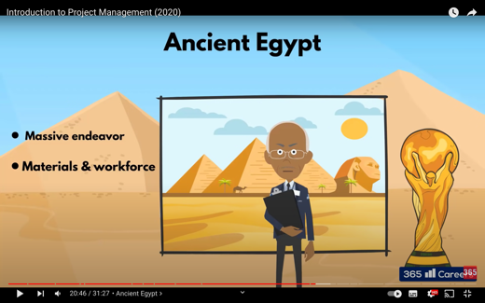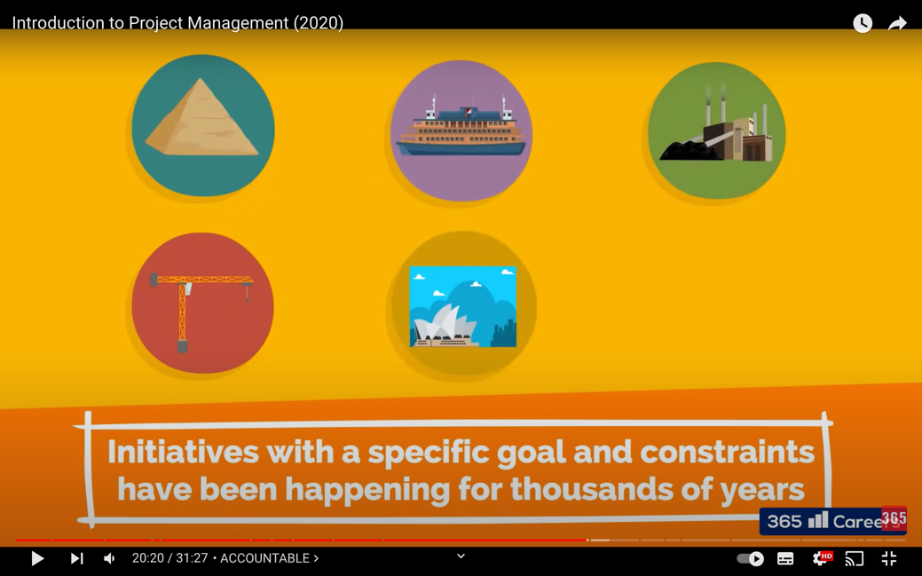

Ancient Egypt: The Great Pyramid of Giza, as one of seven wonders of the world

It’s a good example of the project was massive endeavour with a unique result!

It’s still unknown exactly how the works was organised and executed but its planning and management was something innovative even for today’s standards.

I can’t imagine how that works and still exists there as it was for thousands of years!! Mystery!!

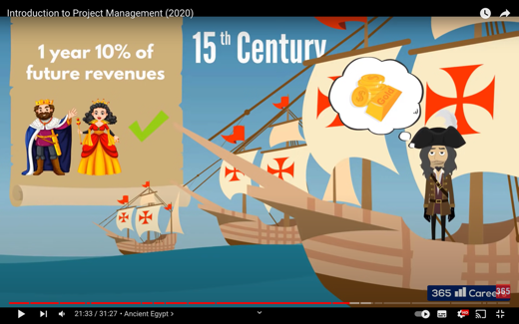

15th Century: Overseas expeditions to find new lands and resources

Cristopher Columbus had three ships and a timeline of one year with a request of 10% of future revenues from any discovers

It must be tough!! He should be a great manager as he kept motivating his crews, planed and directed projects to achieve the goal, and managed their limited budgets and resources…

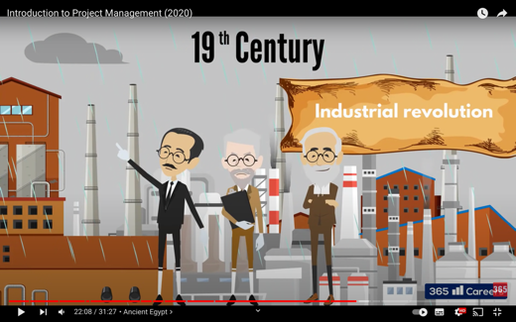19th Century: the industrial revolutions, the beginning of fastest technological grows in recorded history

Automation and mass production changed the face of trade, and the way industries operated

Competition started growing… Big competitions these days are started in this time, and all changed the world and our life a lot.

Japan was also the one of the countries had a big revolution in this age

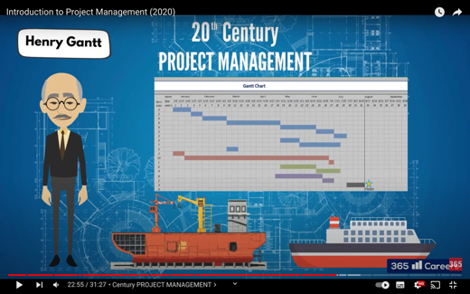20th Century: Project management nowadays is started and developed

Henry Gantt created a first project schedule that a simple yet ingenious table, Gantt Chart Diagram. It is a revolution to know more about project management.

This Gantt chart lists the tasks to be performed on the vertical axis, and time intervals on the horizontal axis.

This chart makes all tasks visible and easy to understand and manage for everybody.

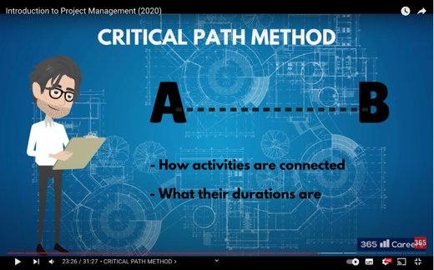In addition, the Critical Path Method was invented by DuPont and Remington Rand corporations.

This helped PM calculate the fastest way to complete the project by analysing the most important tasks in the project timeline, identifying task dependencies, and calculating task durations.

I didn’t know this method so far, but it must be a big help for PM to manage and workers to understand their project visibly by using these methods combined.

## Project terminology

1. 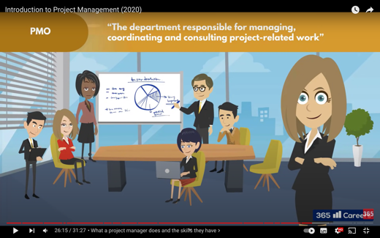Project Management Office

A project management office (PMO) is a group or department that defines, maintains and ensures project management standards across an organization. A PMO can either be internal or external. One can think of a project management office as a regulatory commission that seeks to standardize the execution of projects in order to maintain productivity. A PMO offers guidance to project managers and develops metrics on the practice of project management.

There are project and program managers, project coordinators and analysts, etc., all working to ensure the projects of organizations are properly managed.

1. 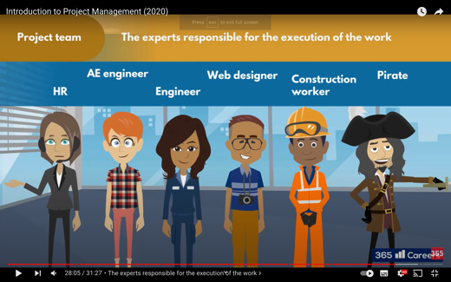Project Team

Project teams are comprised of many different roles such as project manager, subject matter experts, business analysts, and other stakeholders.

A team can be from different departments and can also include external employees or companies and vendors such as consultants, coaching professionals, hardware and equipment vendors, etc. Joint teams are created often connecting employees from more than one company. This is one way to ensure the project team has broader expertise and the capabilities to deliver a more complex project.

1. 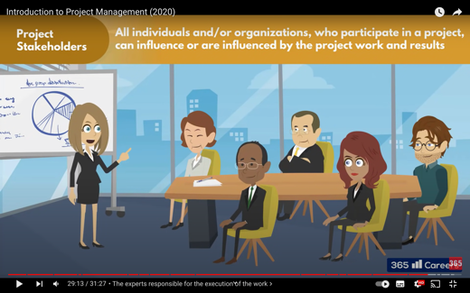Project Stakeholders

Project manager and project team, management customers, competitors, vendors, clients, also everyone who can influence and/or are influenced by the project work and its results are stakeholders even without being involved in the project itself.

PM need to keep all stakeholders informed, involved, and on-board throughout the project’s progression. Stakeholder happiness is one of the key metrics of a successful project.

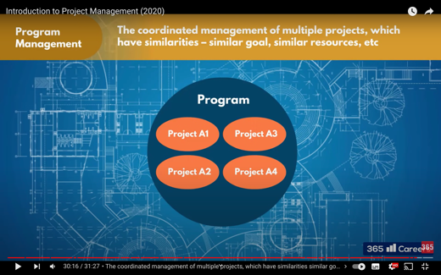

1. Project Management

Project management is the coordinated management of multiple projects, which have similarities by managing them as a program the organizations gains advantages by realising efficiencies and synergies.

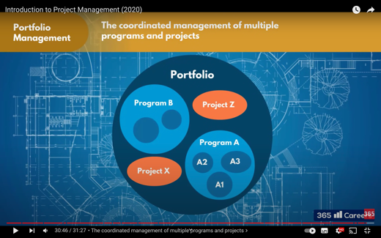

5) Project Portfolio Management

Portfolio management is the coordinated management of multiple programs and projects used to structure and manage investments at an organisational or functional level to optimise strategic benefits or operational efficiency. Portfolio management is the selection, prioritisation and control of an organisation’s programmes and projects, in line with its strategic objectives and capacity to deliver.

Project portfolio management is fundamentally different from project and program management. Project and program management are about execution and delivery---doing projects right. In contrast, it focuses on doing the right projects at the right time by selecting and managing projects as a portfolio of investments. It requires completely different techniques and perspectives. Good portfolio management increases business value by aligning projects with an organization’s strategic direction, making the best use of limited resources, and building synergies between projects.

## Document Search Index

A

a GANTT chart · 3

Action plan · 9

C

control risk · 8

E

Expert judgment · 13

I

Integration management · 5

ISA 315 · 7

K

Kill points · 10, 12

M

mission and strategy · 6

mission statement · 5

O

organizational change · 7

P

Project Management · 9, 19, 20

Project Management Office · 19

project phase · 10, 12

Project Portfolio Management · 20

Project Stakeholders · 20

Project Team · 20

S

Strategy implementation · 6

successful implementation · 5

T

The project management triple constraint · 16

U

understanding risk · 7

V

vision statement · 5